Homework Assignment 2

Zach Kushnir - 4367785

1- Cost function

1. Cost 1 - 29.6563
2. Cost 2 - 14.8750

2- Gradient Descent

theta =

0.2675

0.9612

Cost = 19.8954

3- Normal equation

theta =

4.0000

2.0000

There is a major difference between my estimates for theta for question 2 and 3. This is likely because in question one we only iterated for 15 iterations. If we had more iterations, the approach in question 2 would most likely converge to the same solution as the second approach.

4- Linear regression with one variable

1. MATLAB
2. Image:

ps2-4-b.png

1. Text output:

Size of X: 179x2

Size of y: 179x1

1. MATLAB
2. Theta = [-5.8646 17.8308]’

ps2-4-e-1.png

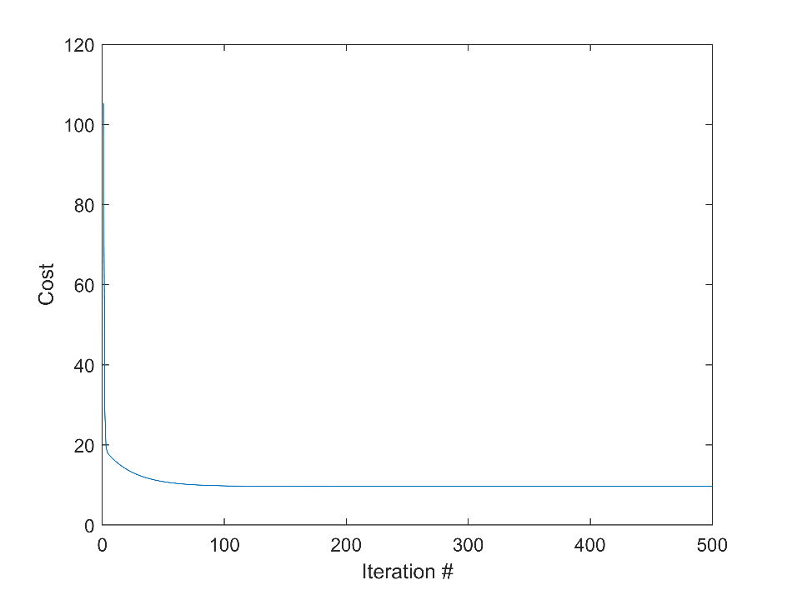

ps2-4-e-2.png

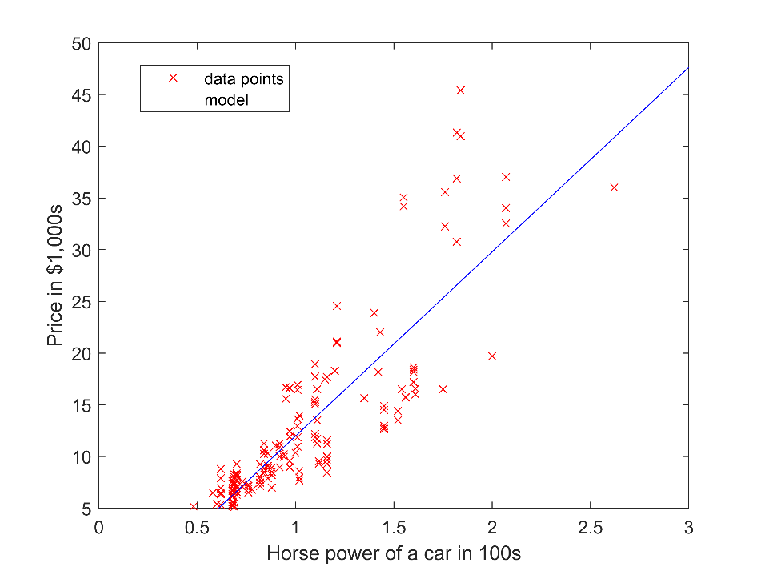

1. Error: 4.4669
2. Error: 4.4669. The error from of predicted y values using the normal equation parameters is the same as the error from the gradient descent function. This is a good indication that the gradient descent algorithm converged to a solution.
3. Images 1-3 all decrease in cost as iterations increase. The second largest alpha out of the four, .03, converges to the smallest cost the fastest. The largest alpha is too large and diverges, the cost ramps up towards infinity as iterations increase. The smallest alpha as shown in the first image decreases very slowly and with only 300 iterations the cost does not go down as well as the second and third lowest alpha values.

ps2-4-h-1.png

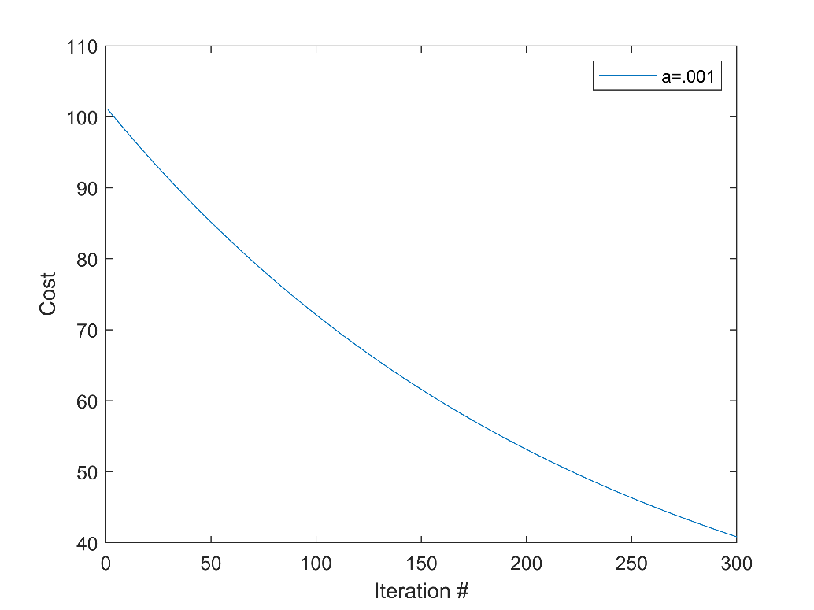

ps2-4-h-2.png

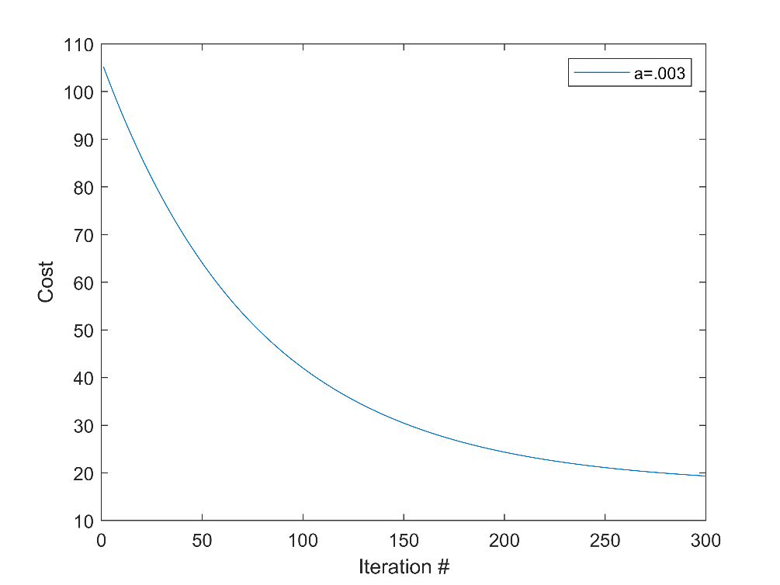

ps2-4-h-3.png

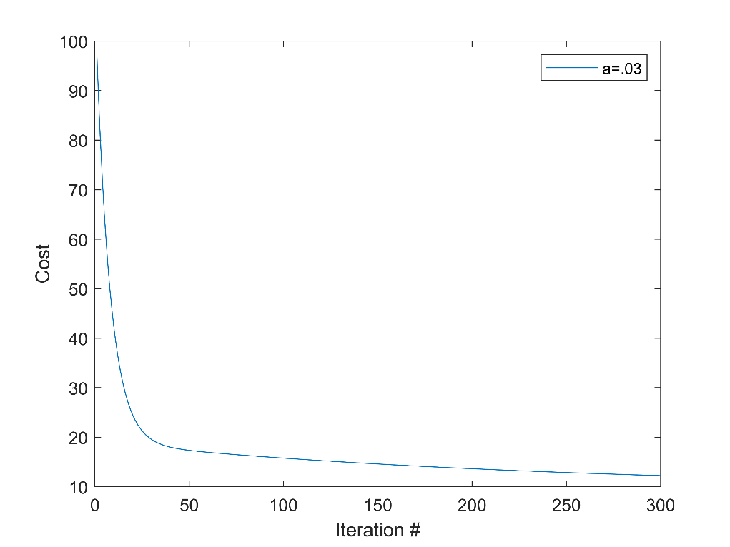

ps2-4-h-4.png

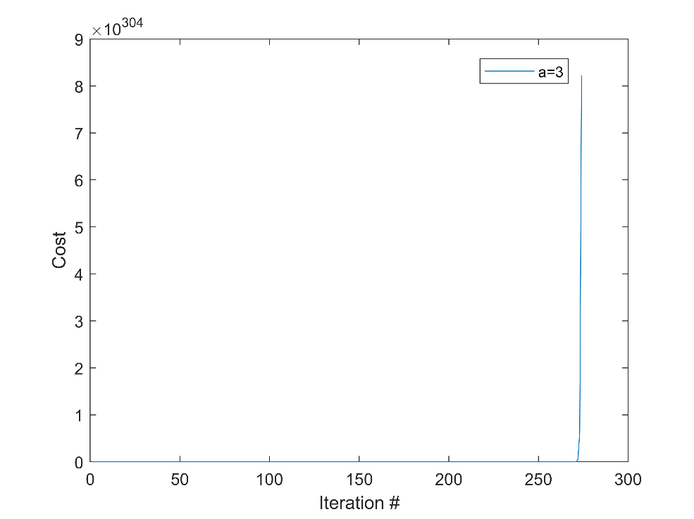

5- Linear regression with multiple variables

1. Text output:

Mean for feature 1: 2000.7

Mean for feature 2: 3.2

Standard Deviation for feature 1: 794.7024

Standard Deviation for feature 2: 0.7610

Size of X: 47x3

Size of y: 47x1

1. Model parameters:

theta =

1.0e+05 \*

3.4023

1.0835

-0.0438

ps2-5-b.png

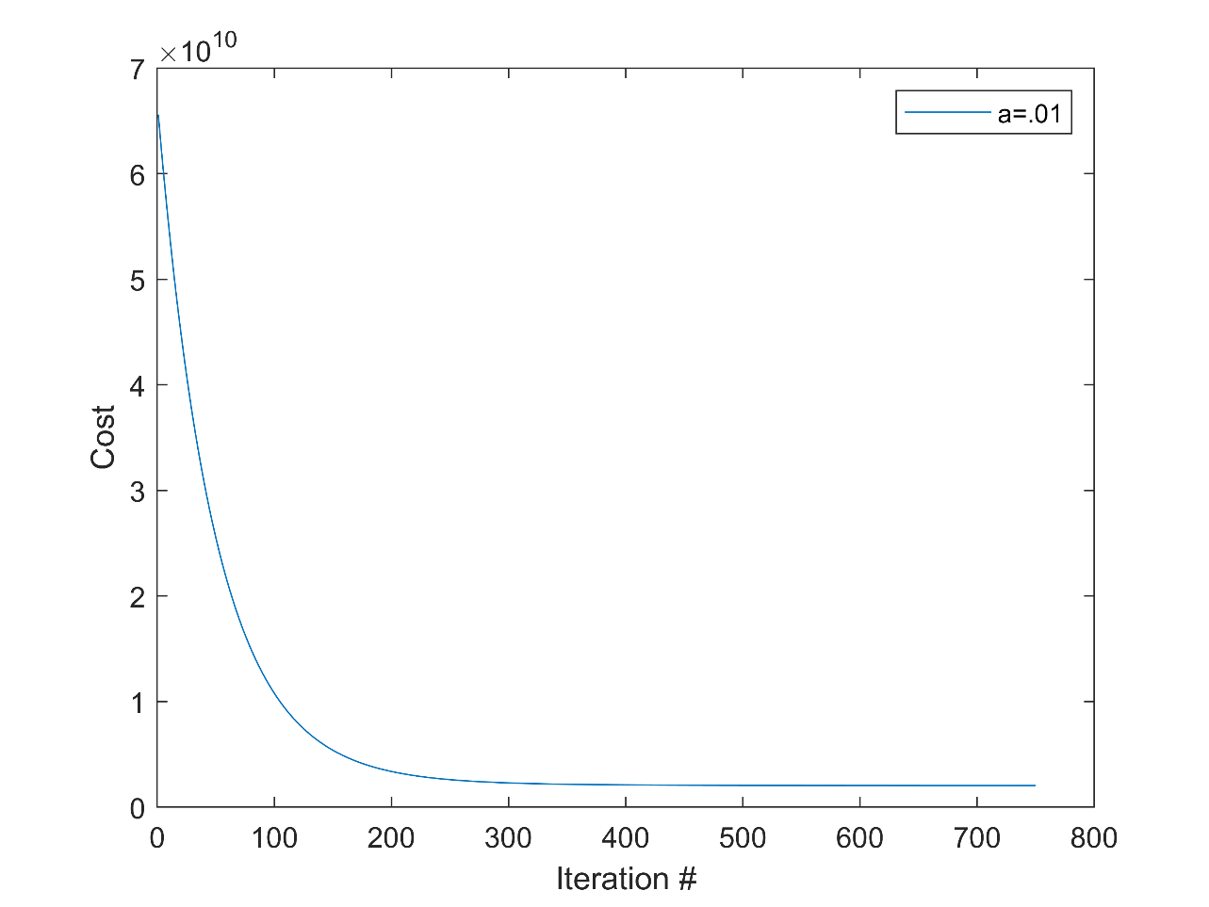

1. Prediction: 221,430